Dave Phillips

2021-07-10

IT FDN 110 A Su 21: Foundations Of Programming: Python

Module 1 – Assignment 1

Our Very First Script! (Hello, me!)

# **Introduction:**

In this assignment we’ll be coding a variation of the traditional “Hello, world” first-timer code. The application will greet the user, request their name, and greet them in turn before terminating.

# **Code Overview:**

The full block of code for this assignment can be viewed below. We will break it down into chunks to examine the functionality of each section (Figure 1).

1. #==================================================#
2. # Test Script -- test.py --
3. # C:\Users\Alleg\Python\UW Course\Week 1\test.py
4. # Assignment #1 - Display user's full name
5. **# DJP -- 2021-07-09 -- Initial script composition**
6. #==================================================#
7. **print**("Thank you for using the name query tool!**\n**")
9. firstName = input("Please enter your first name...|| ")
10. **lastName = input("And your last name...|| ")**
12. **print**("**\n**Surprisingly, your name is ||", firstName, lastName, "||")
14. input("**\n\n**Press Return to terminate")
16. # test.py

Figure 1. – Full code block

# **Discussion:**

To begin, lines 1-6 are initial comments. They give basic information regarding the module for easy reference in the future – including file name, file path, assignment summary, and change log (Figure 2).

1. #==================================================#
2. # Test Script -- test.py --
3. # C:\Users\Alleg\Python\UW Course\Week 1\test.py
4. # Assignment #1 - Display user's full name
5. **# DJP -- 2021-07-09 -- Initial script composition**
6. #==================================================#

Figure 2. – Basic module data

Following setup we have an initial **print** statement welcoming the user to our extremely fancy application. This is going to take us far, so we need to ensure the user feels comfortable. In lines 9 & 10, the **input** statements request both a first name (stored in object “**firstName**”), followed by a last name (stored in object “**lastName**”).

Line 12 is where the magic happens (Figure 3). This print statement not only writes preset text to the screen, but additionally concatenates the first and last name into the message. Commas separating elements of the statement automatically add spaces, so there’s no need to add them into the content itself. (This is contrary to the ‘**+**’ operater which does *not* insert spaces.)

1. **print**("**\n**Surprisingly, your name is ||", firstName, lastName, "||")

Figure 3. – This is the magic.

Lastly, line 14 is a closing message both alerting the user that the script as concluded running and will terminate upon pressing the “**enter**” key. The command line window will either close or return to the base prompt depending upon how the module was run.

# **Summary:**

Upon executing and proceeding through the app, the command line window will display the following (Figure 4):

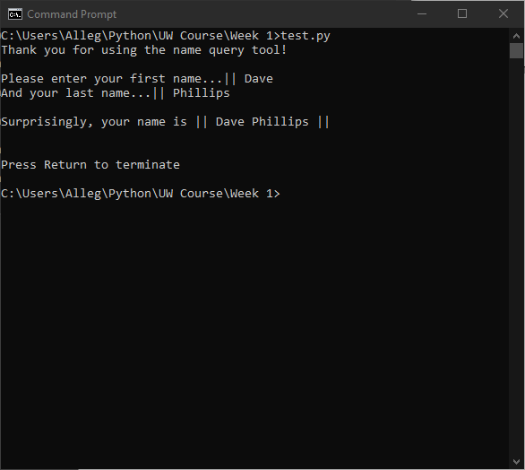

Figure 4. – Successful execution of the script via command line.

As you can see, there was success when executing the code, and we have greeted the user very stylishly. Additional functionality planned includes a GUI, SQL database integration, and automatic sandwich making capabilities.